Reuben Ukah

Project Part 2.

11/20/2019

Reuben Financial CO. Bank System Documentation

Screenshots:

Main application



1. Deposit







ii. Withdraw









1. Transfer





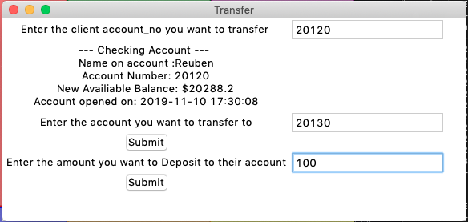







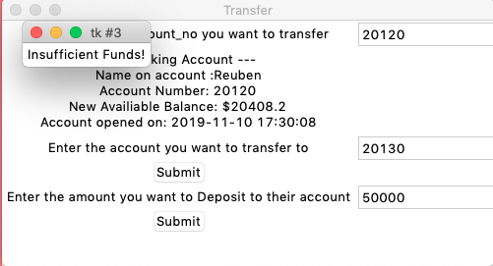

ACID properties

1. Atomicity







ii. Consistency

My program has this property, because if you look at the atomicity section, when I closed the program with the control-c. My program was able to retain the same rows that it had before. The rows did not change at all.

iii. Isolation

It froze

